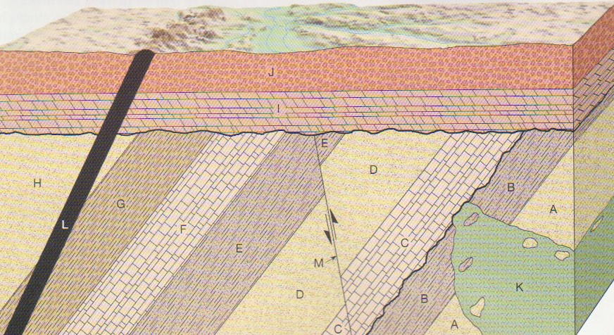

Youngest

_______Erosion

_______Dike L

_______J

_______I

_______Erosion

_______Fault M

Fault M must be younger than E, but it could have occurred anywhere in between F, G, H, Tilting, and Erosion. All we know for sure is that is happened after E but before the next erosion event.

_______Tilting

_______H



_______G

_______F

_______E

_______D

_______C

_______Erosion

_______Tilt

_______K

_______B

Oldest

_______A

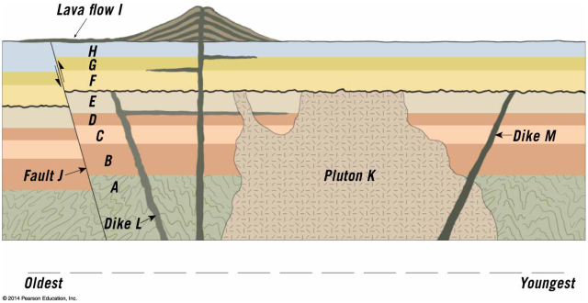

Youngest



_______Lava Flow I (with dike, sills, and volcano)

_______Erosion

_______Fault J

_______H

_______G

_______F

_______Erosion

_______Dike M

_______Pluton K

_______Dike and Sill L

_______E

_______D

_______C

_______B

Oldest

_______A

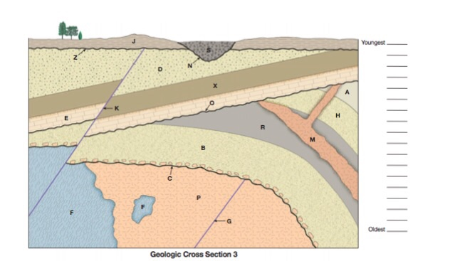

Youngest



(Metamorphic)

(pluton)

In this diagram, the unconformities are assigned their own letters, but please still list them in your list of events as “erosion” – this is what I will require you to do on the test

_______S

_______Erosion of channel (N)

_______J

_______Erosion (Z)

_______Fault K



_______Tilting

_______D

_______X

_______E

_______Erosion

_______Dike M

_______Folding

_______A

_______H

_______R

_______B

_______Erosion

_______Pluton P

_______Metamorphic F

Oldest